REPORT ON OPTIMAL NEEDLE REPLACEMENT POLICY
ITESO – Master’s Degree in Data Science – Predictive Modeling – Fall 2026
Acoyani Garrido Sandoval, Israel Rivera Guzmán, Margarita Flores Ruiz, Oscar Gutiérrez Godoy & Emilio Valerio Padilla

- EXECUTIVE RECOMMENDATIONS

- Optimal needle replacement schedule: Every 5,000 operating hours.
  - Acceptable replacement range: 4,250 – 5,000 hours
  - This replacement schedule yields a calculated operating cost of $2,335/thousand hours, vs. $4,058/thousand hours if the needles are run until failure. With this schedule, failures have been calculated to drop from 30 to 4 over the five year history.
  - Validated on machines not used to choose it, the policy saved 33-44%, and the optimal threshold stays at 4,500 – 5,000 hours whether a failure’s productivity loss is $10,000 or $40,000.
  - A fixed hour policy is recommended over a sensor-based one because no model could predict needle lifetime from operating conditions; risk is driven by accumulated hours.

- DATA QUALITY ISSUES

The raw file contained 2,605 machine-week records. After removing 5 exact duplicates, the data held exactly 2,600 rows: 10 active machines in each of the 260 weeks, as the case specifies. Season labels appeared in 11 variants (e.g., "Wnter", "Summmer", "AUTUMN"); 28 records were standardized to the four valid seasons. Sensor values outside 3×IQR, or outside physical limits (relative humidity above 100%), were treated as recording errors and set to missing. We used 3×IQR rather than 1.5×IQR so that legitimately hot or fast weeks are kept and only implausible values (e.g., 138 °C, 168% humidity, 2,569 RPM) are removed. Missing values were then filled with each column's median, which is not distorted by the removed outliers.

Issue | Rows | Treatment
Exact duplicate rows | 5 | Removed
Misspelled / miscased Season labels | 28 | Standardized to 4 seasons
Temperature_C extreme outliers | 10 | Set to NaN (outside [-0.6, 51.2])
Humidity_Pct extreme outliers | 8 | Set to NaN (outside [-1.7, 100.0])
Fabric_Thickness_mm extreme outliers | 6 | Set to NaN (outside [0.5, 11.1])
Machine_Speed_RPM extreme outliers | 8 | Set to NaN (outside [643.2, 1221.3])
Vibration_mm_s extreme outliers | 8 | Set to NaN (outside [1.2, 4.6])
Missing values: Temperature / Humidity / Thickness / RPM / Vibration / Shifts | 56 / 49 / 37 / 28 / 38 / 15 | Filled with column median

- EXPLORATORY ANALYSIS AND FEATURE ENGINEERING

Grouping the weekly records by Needle_ID gives 45 needles: 30 failed in service, 5 were replaced preventively, and 10 were still running at the end of the horizon (right-censored: their true lifetime is unknown). Failed needles lasted between 3,420 and 9,585 operating hours (median 6,210 h, mean 6,279 h, standard deviation 1,477 h). No needle failed before 3,000 hours.

Failure risk rises clearly with accumulated use, a wear-out pattern. The weekly failure rate is 0% below 3,000 h, about 0.3–0.8% between 3,000 and 5,000 h, 3–4% between 5,000 and 7,000 h, and 6–14% above 7,000 h. The seasonal effect is small (weekly failure rate 0.8% in winter, 0.9% in autumn, 1.4% in spring, 1.5% in summer) and rests on only 30 failures, so we treat it as weak evidence.

Cumulative hours | 0–3,000 | 3–4k | 4–5k | 5–6k | 6–7k | 7–8k | 8–9k | 9–10k
Weekly failure rate | 0.0% | 0.8% | 0.3% | 4.1% | 3.0% | 11.4% | 5.6% | 14.3%

- MODEL CONSTRUCTION AND VALIDATION

Classification: does the needle fail this week? Each machine-week is one observation (2,600 rows, 30 failures, about 1.2%). To avoid leakage, predictors are limited to information known at the start of the week: cumulative hours at the start, weekly working hours, the five operating conditions and season. Cost columns, replacement flags and end-of-week hours were excluded because they reveal the outcome. Validation has two layers: a time-ordered back test (train on weeks 1–182, test on weeks 183–260: 19 and 11 failures) and 5-fold stratified cross-validation inside the training period. Because failures are rare, accuracy is uninformative (predicting "no failure" always would score 98.8%); we report AUC, recall, precision and F1, and used class_weight="balanced" (or equal priors for LDA).

Model | CV AUC (sd) | Test AUC | Test recall | Test precision | Test F1
Logistic regression | 0.822 (0.069) | 0.906 | 0.818 | 0.048 | 0.091
PCA(4) + logistic | 0.702 (0.162) | 0.771 | 0.909 | 0.035 | 0.068
LDA | 0.846 (0.054) | 0.905 | 0.818 | 0.045 | 0.085
LDA(1) + logistic | 0.846 (0.054) | 0.905 | 0.818 | 0.046 | 0.087
SVC (RBF kernel) | 0.754 (0.083) | 0.807 | 0.273 | 0.046 | 0.079

Logistic regression and LDA perform best and most stably (test AUC ≈ 0.91; 9 of 11 future failures flagged). PCA hurts, likely because unsupervised components dilute the cumulative-hours signal among the sensor variables, and the RBF SVC is less stable with so few positive cases. Precision is low (about 5%) for every model: with a 1% base rate, any useful alarm produces many false alarms.

Regression: how many hours will a needle last? One row per failed needle (n = 30); predictors are the needle's average operating conditions and weekly hours. With only 30 cases a holdout split is not reliable, so all models were evaluated with 5-fold cross-validation and compared with a baseline that always predicts the mean lifetime.

Model | CV R² | CV MAE (hours)
Linear regression | -0.840 | 1,510
PCA(2) + linear (PCR) | -0.303 | 1,366
PLS (2 components) | -0.581 | 1,439
SVR (RBF kernel) | -0.216 | 1,260
Baseline (mean lifetime) | -0.118 | 1,239

No regression model beats the mean-lifetime baseline. Within this data, a needle's lifetime cannot be predicted from its operating conditions; failure risk is driven by accumulated hours. This explains why the classifiers work (their strongest input is cumulative hours) and it supports a fixed-hour replacement policy: a model-based risk policy (replace when predicted weekly risk exceeds a threshold) reduces in practice to an hour threshold, while adding model complexity and false alarms.

- COST OPTIMIZATION AND BACK TESTING

Each needle's observed history was replayed under a fixed threshold T, evaluated from 3,000 to 10,000 hours in 250-hour steps. If the needle failed before reaching T, the event costs $30,000 (replacement plus lost productivity); if it reached T, it is replaced proactively for $10,000. Policies are compared by cost per 1,000 operating hours, because shorter thresholds also use fewer hours of each needle. As a check, the simulation with T = ∞ (run to failure) reproduces the data exactly: 30 failures and $950,000. In this data the current practice is essentially run to failure (30 failures, only 5 preventive replacements).

Policy | Failures | Replacements | Total cost | Operating hours | Cost / 1,000 h
Run to failure (≈ current) | 30 | 35 | $950,000 | 234,090 | $4,058
Fixed T = 3,000 h | 0 | 39 | $390,000 | 127,215 | $3,066
Fixed T = 4,500 h | 3 | 36 | $420,000 | 174,240 | $2,410
Fixed T = 5,000 h (minimum) | 4 | 36 | $440,000 | 188,415 | $2,335
Fixed T = 6,000 h | 14 | 36 | $640,000 | 210,720 | $3,037

The cost frontier reaches its minimum at T = 5,000 h ($2,335 per 1,000 h, 42% below run to failure, with 4 failures instead of 30). The minimum is a flat region rather than a point: any threshold between 4,250 and 5,000 h stays within 8% of the minimum. Beyond 5,000 h, cost climbs quickly as failures accumulate.

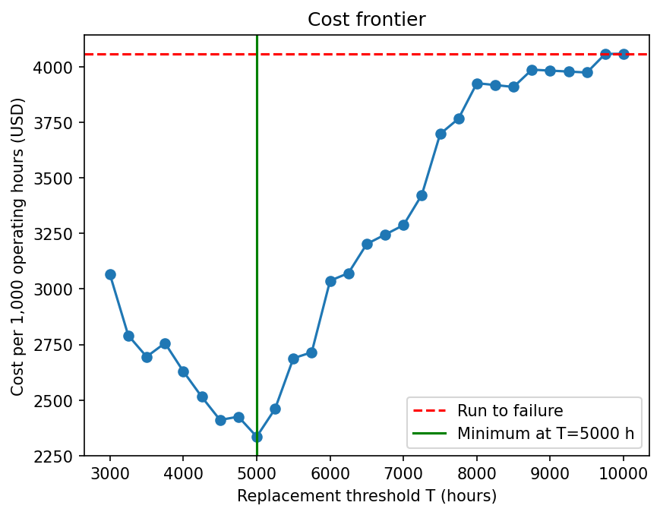
Back test: to check that the threshold generalizes, T was chosen using only some machines and evaluated on machines left out (3-fold cross-validation by machine).

Test machines | T chosen on train | Policy cost / 1,000 h | Run to failure | Saving | Failures (policy vs RTF)
1, 2, 3 | 5,000 | $2,297 | $3,668 | 37.4% | 1 vs 8
4, 5, 6 | 5,250 | $2,489 | $4,444 | 44.0% | 2 vs 10
7, 8, 9, 10 | 5,000 | $2,703 | $4,066 | 33.5% | 3 vs 12

Sensitivity: varying the productivity loss per failure from $10,000 to $40,000 moves the optimal threshold only between 4,500 and 5,000 h (cost per 1,000 h: $2,123, $2,335 and $2,755, against $2,777, $4,058 and $6,621 for run to failure). The higher the cost of a failure, the larger the saving and the earlier the optimal replacement. The recommendation is robust to the main cost assumption.

- LIMITATIONS

The dataset includes 10 censored needles (needles whose full lifespan could not be observed due to end of data gathering, meaning we don’t know their exact lifespan, only a lower bound), as well as 5 preventively replaced needles (this blocks us from observing their full lifespan). As a result, averaging only the 30 failed needles would lead us to underestimate the typical lifetime of a needle, as the long-lived ones are disproportionately the ones still running.

The number of observed failures is small, at only 30 failures. This implies wide uncertainty; to address this, the replacement schedule is also reported via a range.

The simulation relies on a simplified model where the machines do not change, the conditions are always constant, replacement is considered instant, and costs are fixed. While this is acceptable to determine an initial iteration of a calculated replacement schedule, this also leaves room for improvement: taking into account the possibility that needle prices could change, the time it takes to replace a needle, the conditions of the machines themselves, etc.

There is also a leakage risk: weekly rows of the same needle are correlated (albeit mitigated by the time and machine splits), and the cleaning medians were computed on the full dataset before splitting.

- CONCLUSIONS

The general recommendation, derived from this exercise, is to replace the needles no later than every 5,000 hours of operation. This replacement schedule yields a calculated operating cost of $2,335/thousand hours, vs. $4,058/thousand hours if the needles are run until failure. With this schedule, failures have been calculated to drop from 30 to 4 over the five year history.

Future work on this case study could include survival analysis through Kaplan-Meier and Weibull models to address the censored and the preventively replaced needles, a more detailed simulation model, or performing a pilot run of the calculated replacement schedule on a few machines to confirm savings.

